  - HKE Socity’S

Smt. C.B. Patil Arts and Commerce
Degree College ,Chincholi

INTERNAL QUALITY ASSURANCE CELL

BRIDGE COURSE PROGRAMME for academic year 2019-20 for B.A/B.Com First year students

Date:26-5-2019 Time 9.30.am

VENUE: COLLEGE FUNCTIONAL HALL

Inauguration / Presiding
Dr. Shrishail Nagaral Principal
Chief Guest
Dr. C. V. Kalaburgi Naac Co-ordinator
Keynote speech
Dr. Manikamma N. Sultanpur IQAC Co-ordinator
Welcome speech
Dr. Laxman T. Asst. Professor in Commerce
Anchoring
Shri. Kashinath Hunaje Lecturer in Kannada
Vote of Thanks
Dr. Siddanna M. Kolli Asst. Professor in Kannada

All are cordially welcome
  - HKE Society’S
  - Smt. C.B.Patil Arts and Commerce Degree College ,Chincholi

Internal quality assurance cell

NOTICE

It is hereby informed that bridge classes on Languages /Commerce and Social sciences will be conducted for all PUC Passed students as per the scheduled given below from 26-5-2019 to 01-6-2019. Hence, all the PUC passed students should attend the classes.
BRIDGE COURSE CLASS SCHEDULE
 | Inauguration | Introduction to Languages | Introduction to Social Science/Commerce
Date | 9.00 -10.00 | 10:00-11:00 | 11.30-12.30
27-05-2019 | Commerce | History | Kannada/English/ Hindi/ Urdu
28-05-2019 | Kannada/English/ Hindi/ Urdu | Rural Development/ Sociology | History
29-05-2019 | Rural Development/ Sociology | Political Science/ Kannada(Optional) | Commerce
30-05-2019 | Economics | Kannada/English/ Hindi/ Urdu | Rural Development/ Sociology
31-05-2019 | Political Science/ Kannada(Optional) | Economic | Economics
01-06-2019 | History | Commerce | Political Science/ Kannada(Optional)

Copy to:
1. All the HODs to circulate among staff.
2..Notice board

IQAC coordinator Principal

To Date: 20-05-2019
The Principal
Smt. C. B. Patil Degree College
Chincholi

Sub: Request to inform and arrange the bridge course for the academic year 2019-20.
*****
With reference to the cited above subject I undersigned Dr. Manikamma N. Sultanpur IQAC Coordinator requesting you to call the staff meeting to discuss academic activities , plan to organize orientation programm and inform to All Departments HOD’s to conduct the bridge course for the academic year 2019-20.

Dr. Manikamma N. Sultanpur
IQAC Coordinator

  - HKE Society’S
  - Smt. C.B.Patil Arts and Commerce Degree College ,Chincholi

Internal quality assurance cell

NOTICE

Hereby informed to all teaching faculty to plan and conduct bridge course by all Departments for the academic year 2019-20. It is well known that most of students are still unaware about topics like language, Commerce and Social Sciences. So make them easy to understand and learn all language and Social Science subjects with confidence. Submit the Activities done report after finishing the one week bridge course on or before 26th May 2019.

Principal

Smt. C. B. Patil Degree College
Chincholi

  - HKE Society’S
  - Smt. C.B.Patil Arts and Commerce Degree College ,Chincholi

Internal quality assurance cell

NOTICE
It is here by informed that Bridge classes will be conducted for all B.A/B.Com Ist Semester Students as per the time table given below. The main objective of the course is to bridge the gap between subjects studied at Pre-university level and subjects they would be studying in B.A/B.Com, Hence all the students are requested to attend the classes without fail to improve your skills.
Principal

Smt. C. B. Patil Degree College
Chincholi

r
  - KE Society’S
  - Smt. C.B.Patil Arts and Commerce Degree College ,Chincholi

Internal quality assurance cell

BRIDGE COURSE REPORT FOR B.A/B.COM 1ST SEMESTER 2019-20

INTRODUCATION

Every individual is unique and possesses special talents. Ample of opportunities, facilities and encouragement are required to express this talent and to strive to take it to great heights. An exposure to art and culture along with physical fitness contributes to the healthy overall development. The Department of Social science & commerce in our college function towards this end. The Department of Social science & commerce to identify the talents in our students and also motivates them to participate in the extracurricular activities and thus boost up art, literature and culture in our college. The Department of Physical Education truly represents the “Health is wealth” Participation in sports inculcates discipline, team skills, and encourages the development of healthy competition. The department identifies and encourages the sporting talent in the students and motivates them to learn the rules and regulations of various games and sports and participate in competitions and tournaments.

A bridge course for newly admitted students is conducted for the academic year 2019-20 before the commencement of the first semester classes. The main objective of the course is to bridge the gap between subjects studied at Pre-university level and subjects they would be studying in Social science. The syllabus for the course is framed in such a way that equal importance is given to all social science and Commerce discipline and personality development which includes soft skills, sports and cultural Activities. The duration of this course is 7 days with 3hrs, for each subject. The students were trained in subjects such as Kannada, English, Hindi, Urdu, Sociology, History, Economics, Political science , Rural Development and Commerce apart from other co-curricular activities. Syllabus for Social sciences and commerce includes concepts learnt at the intermediate level and also additional concepts which are essential prerequisites for B.A. B.Com Programme all Arts and commerce courses. Orientation to soft skills for personality Development with intellectual enhance, which is a part of I year curriculum for all branches. The module on English is aimed at making the students better articulate in English thereby increasing their comprehension level and self confidence. The sessions in the afternoon will be on soft skills, Sports and cultural activities. Bridge Course will help the students to have a smooth transition to the Social science and commerce courses. Also the students who have attended the bridge course in the previous years have appreciated the initiative usefulness.
OVER VIEW OF THE B.A. / B.COM COURSES: TOTAL NO. OF HOURS – 30
Subjects | Hrs
Kannada | 3
English | 3
Hindi | 3
Urdu | 3
History | 3
Sociology | 3
Economics | 3
Political Science | 3
Rural Development | 3
Sports & Cultural | 3
Total Hours | 30

NEED OF THE BRIDGE COURSE
The strength of our relationship with the students is our ability to gauge their strengths and weaknesses. Orientation Programmes and Bridge courses conducted by the different Departments at the beginning of the academic year are an effort on our part to fill-in the chasm that exists between the shared knowledge of students at the entry-level and the course requirements were observed that Gulbarga University CBCS syllabus as it is about 20-30% more vast than the previous state board syllabus. Bridge course helps students to open up, think creatively and become responsible and independent students. The objective of the Bridge course is to clarify what is expected of students in Pre University-level classes and to provide adequate foundation in the core applied science subjects and English limited to moderate level so that students do not face any difficulty when the classes commence. To phase in students to social science, commerce and enjoy education, overview through project based learning is also envisaged. The sessions also include ice breakers, Sports and Cultural Activities for all round development. During this interaction of few days with the faculty, the students will come out of their hesitation and it will be the best platform for the students to interact with the faculty members, making it responsible for them to build strong relationships with faculty, advisers and other students.

This course was conducted for academic year 2019-20. The statistics show that, there is a gradual improvement of more than 30-50% in the overall performance of the students. Sociology is mother of all Social sciences. It is one module on Society is incorporated in the fundamental infrastructure of society, function of social system, Uses of sociology, Development and Significance , community, behavior, social relationship, Interaction, association, organization, m Significance of Culture, Socialization, Social stratification, Mobility, social change, Social control bridge course. It would enable the students to curriculum. However, there is a gap in the grasp the concepts of Sociology quickly and sociology learnt at the intermediate level and the efficiently in the Bachelor of Arts programme. To bridge this gap and that they gained confidence from the bridge strengthen the fundamentals of the students, a course in especially sociology subjects

PROGRAMM INTRODUCTION

Smt. C.B Patil Arts and Commerce Degree College Chincholi started in the year 1983. Now almost after completion of 36 years we are having 2 programmes branches with intake of 400 and 200 for B.A /B.com students in under graduate level. After attending the rigorous brain storming sessions and training programs our faculty members associated with 1st year program along with higher authorities and management collectively realized the importance of bridge course. In spite of having very good grades at Higher Secondary Exam, students had long break since the month of April. It is well known that most of students are still unaware about topics like communication skills, public speaking, building confidence because of shift from vernacular to English language. Students face an immense pressure of studying all the subjects in English. This sudden transition makes some of them feel low. Looking to above points, it was felt to take holistic approach in implementation of bridge course. By taking this 1 week seriously and sincerely, the difference in our students, is visible and feel more confident.
OBJECTIVE
The bridge course is acting as a safeguard for new students, and is acting as a bridge to initiate the hardcore social science subjects with ease. This course includes foundation subjects like basic 10 + 2 level Kannada, English, Hindi, Urdu, History, Sociology, Rural Development, Political Science, Economics, Computer science Elements of subject matter Information and Communication technology, according to CBSC syllabus. These 6 days program will enable students to prepare for the 1st year Social Science and commerce subjects with confidence.

Overall in BA Ist Semester we have 4 combination and 48 classes in Social Science branch i.e. 30 seats in Kannada, Sociology 30 seats in Computer Science Branch, 30seats in Economics 30 seats in 30 seats in Rural Development, 30 seats in Political Science, 30 seats in Economics, 30 seats in Commerce Branch, 30 seats in Computer science Branch. In the orientation program, the students and parents were informed about the Bridge course. The importance of Bridge Course was emphasized. Moreover, the students were informed about the content of Bridge course, the detailed content of all the subjects was briefed. Students were also told about the anti ragging committee rules. Female students were told about the activities which come under Women Development Cell of our institute.
COMMENCEMENT OF CLASSES
For all the 30 classes, coordinators and Co-coordinators /HOD were identified who enable all the students of their respective classes with all the facilities. Those coordinators were acting as their counselors as well as facilitators and mentors for all the bridge course activities. These faculty members in class were acting as point of contact for the students who were sharing their thoughts or activities to be included or not in the bridge course. On the last day the students appeared for MCQ based test for subject’s conducted by Kannada, English, Hindi, Urdu, History, Sociology, Rural Development, Economics, Political science , sports, Life skills and basic computer skills. After two days of examinations they felt that this test will enable them to know how much further learning is required.
CONCLUSION
Bridge course in the institute was welcomed with a positive note by all the staff members on a short notice. Thus, this enhanced the confidence of the student’s specially speaking, writing, reading in Kannada, English and Hindi. Bridge course has produced awareness amongst student’s about learning effectively and revising basic subjects will help them comfortably study their core Social science and commerce subjects with ease. On the whole, this journey of 6 weeks was joyful and informative.

OUTCOME OF THE BRIDGE COURSE

- It has provided students the confidence and skills to successfully transition to college.
- Students have been Familiarize with Smt. C. B. Patil Degree College and its resources.
- It has Built Positive relationships between new students and peers, faculty, and staff at Smt. C. B. Patil Degree College Chincholi

- It has assisted students in their personal development of life skills, ethical judgment and moral fortitude.

- It has helped students for enhancing critical thinking skills through self-exploration and class experiences.

- Student will able to develop strategies and resources for students to balance school, work, and personal commitments.
- It has given exposure to college life in a structured and supportive learning community.

Dr. Manikamma N. Sultanpur
Bridge course Coordinator
GALLARY OF BRIDGE COURSE:
Bridge Course inauguration

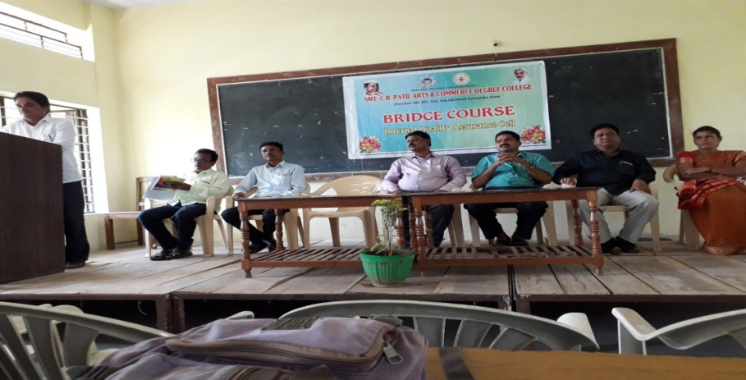
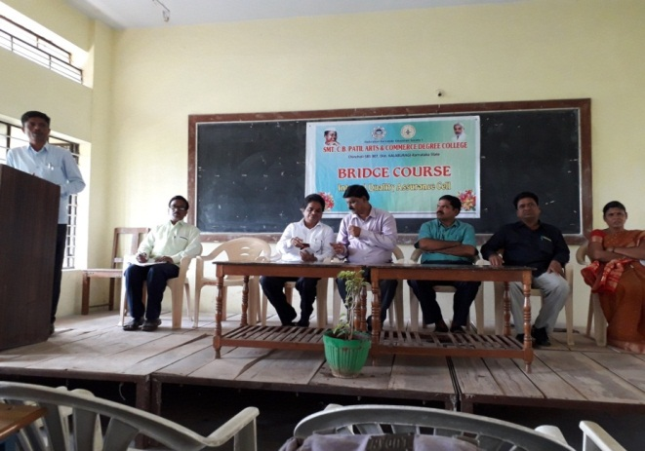

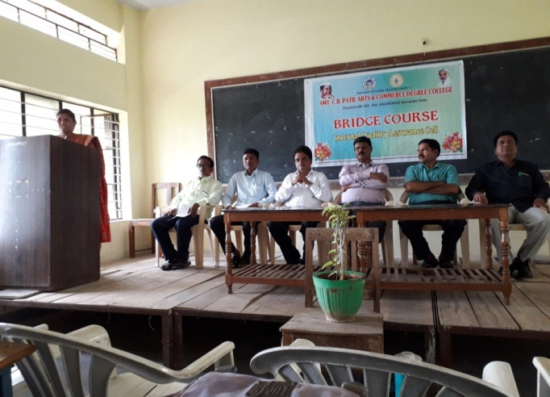
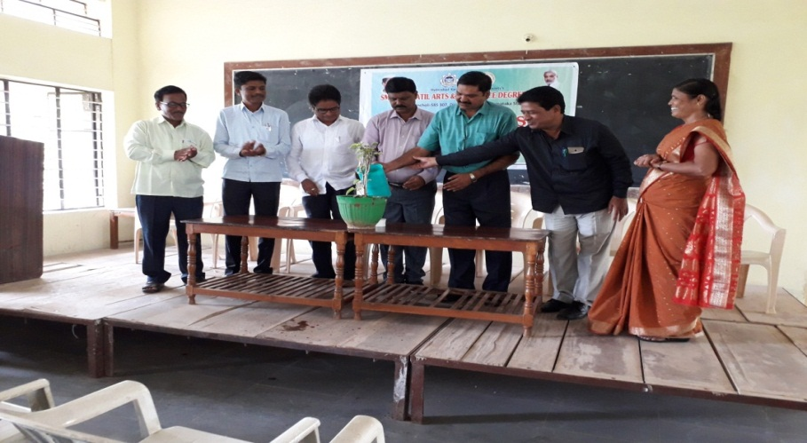

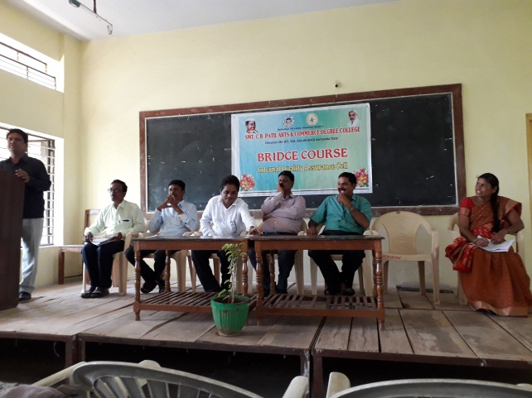
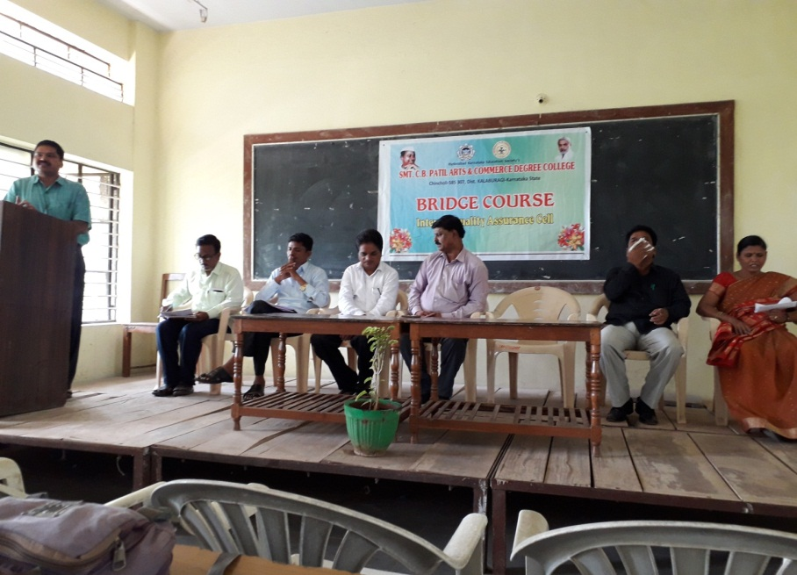

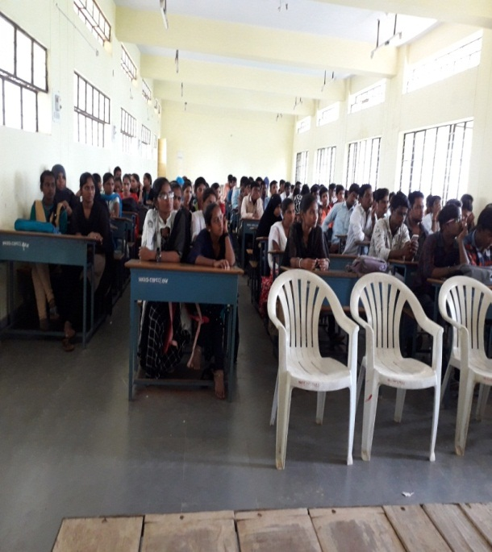
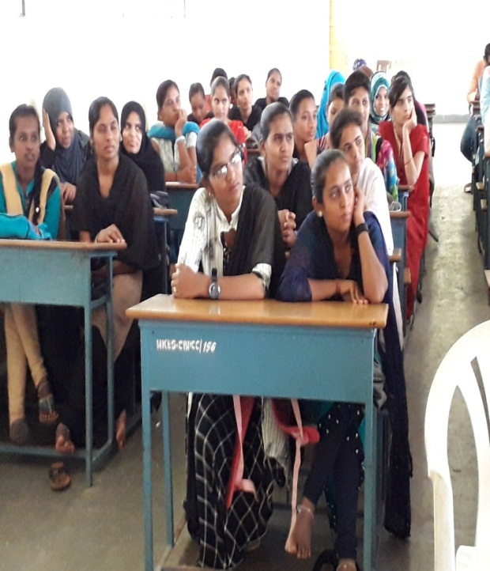
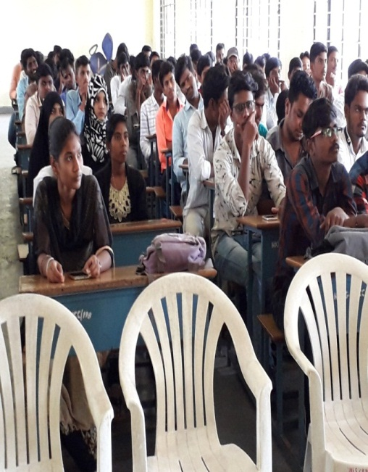

Bridge course of Dept of Kannada
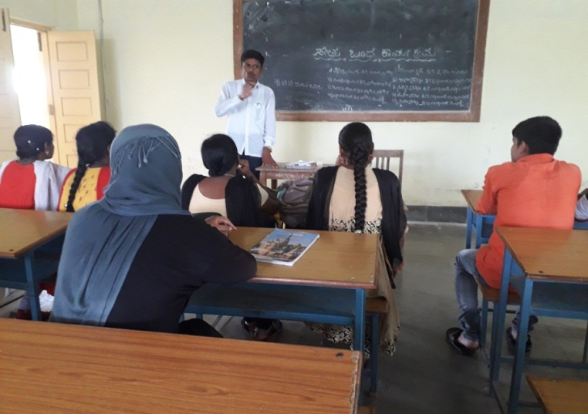
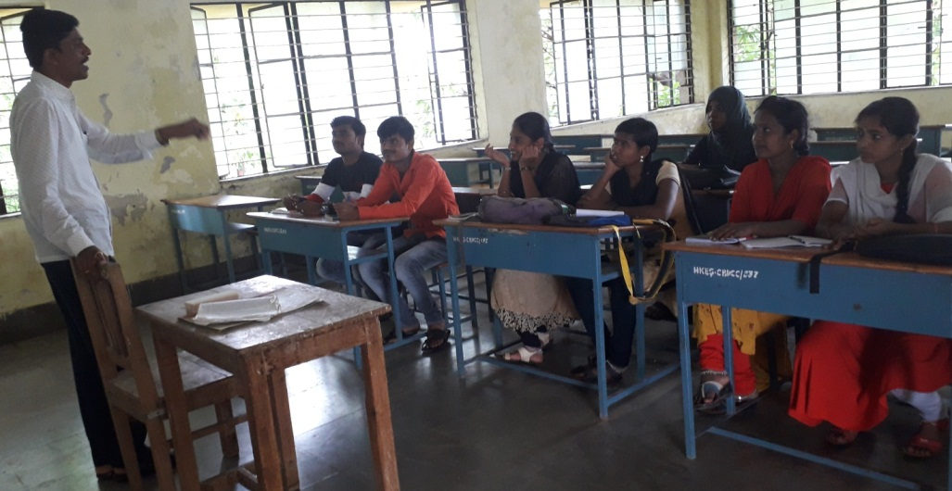

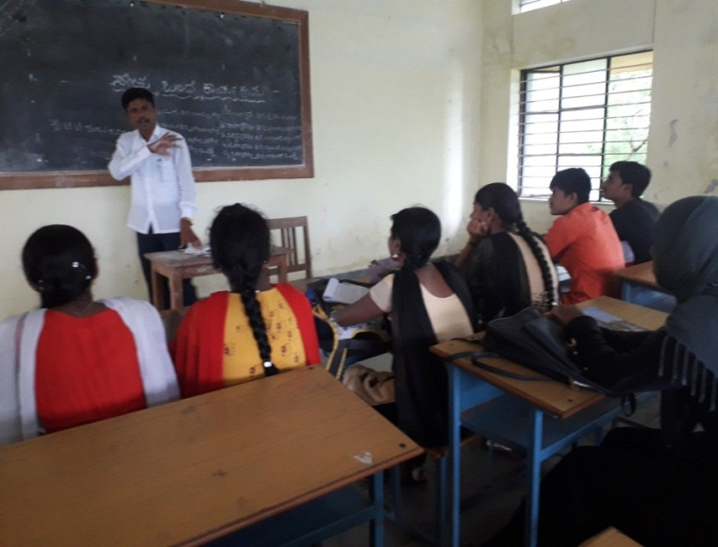
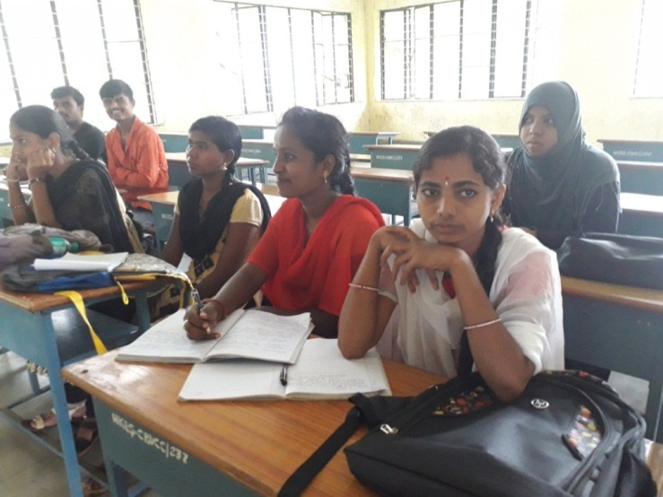

Dept. of Sociology

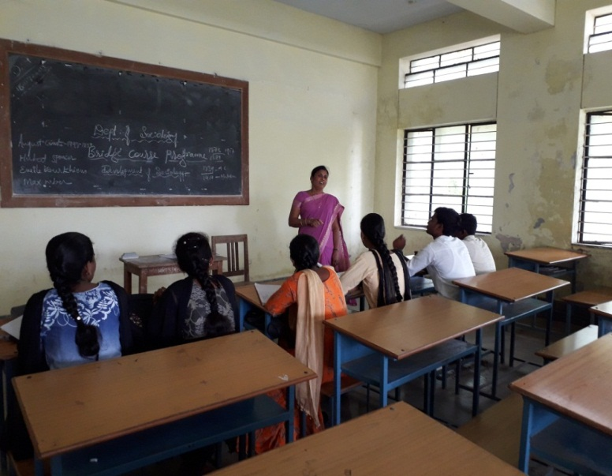
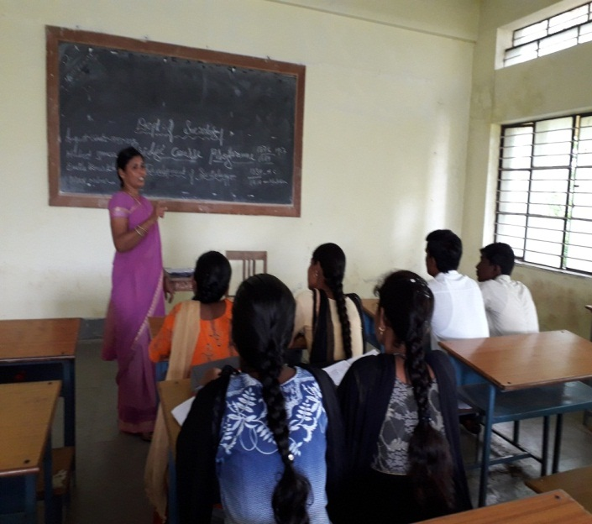

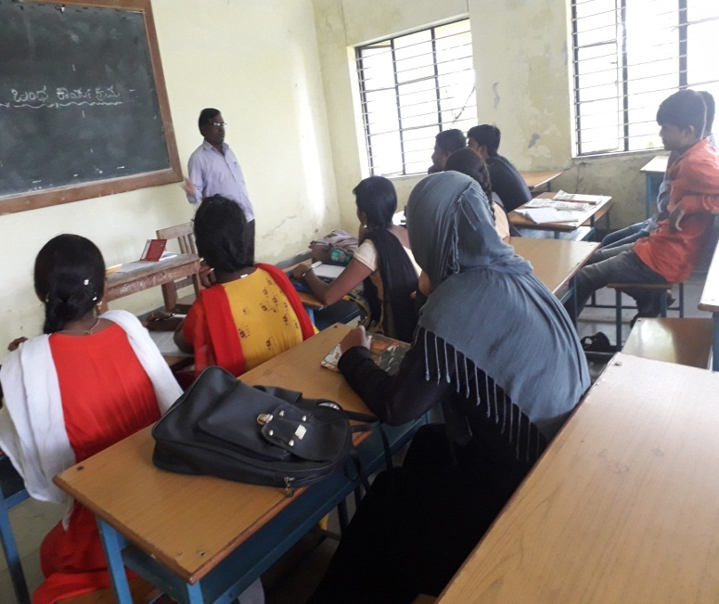
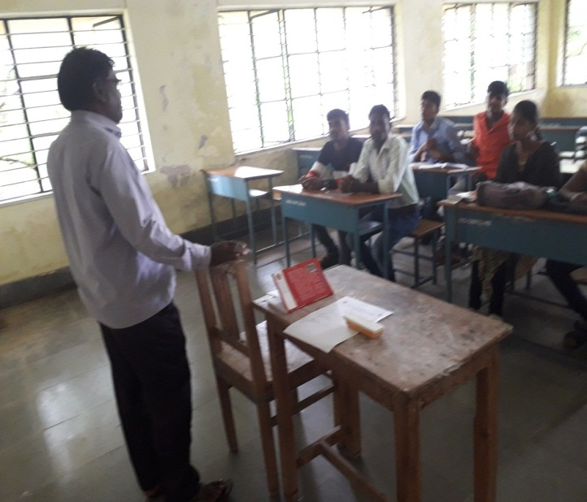
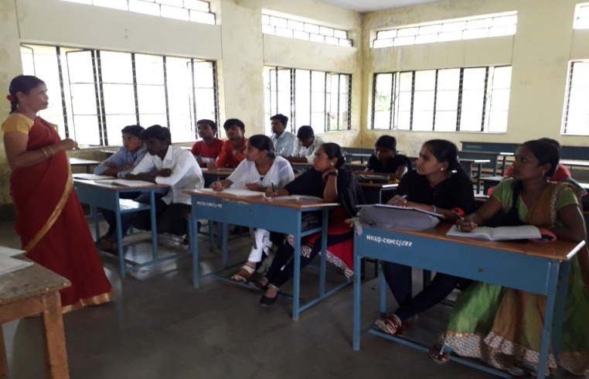

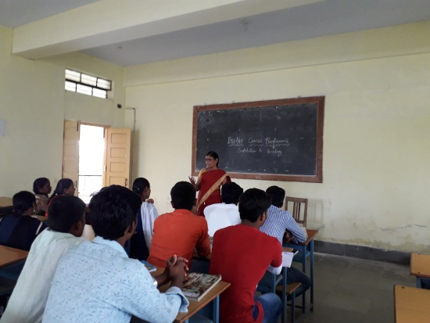

Dept. of Economics

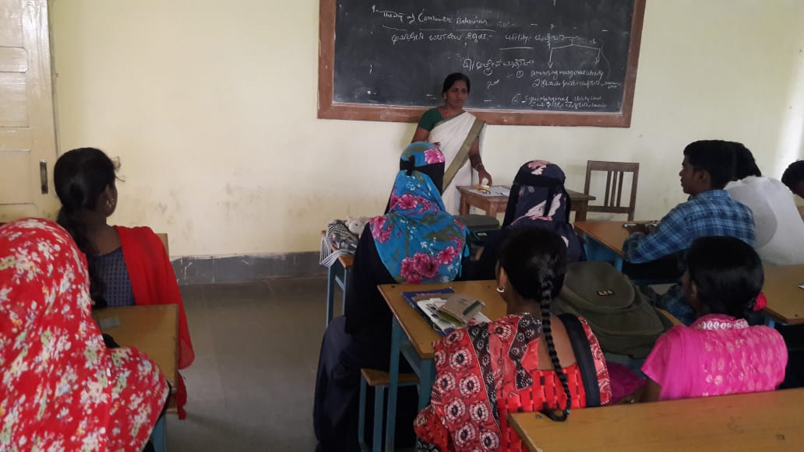
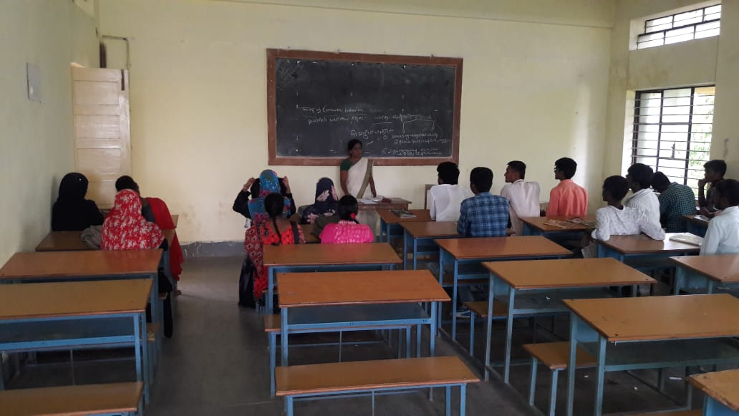

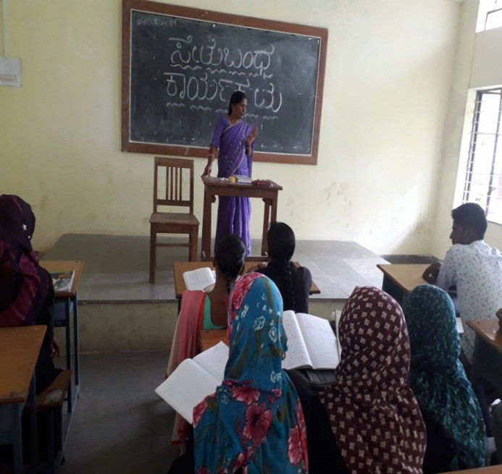
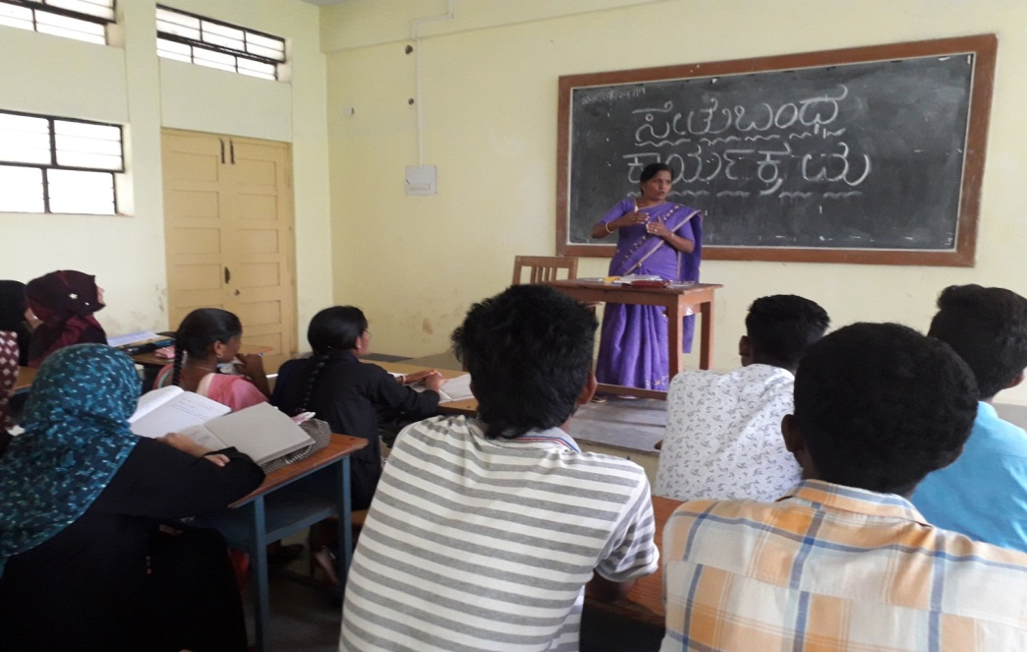

Dept of Political Science

